SPECIFICATION DOCUMENTATION

|  |  |  |  |
| --- | --- | --- | --- |
| Version | Description of change | Author | Date |
| 1 | Initial documentation | **NAME:** Elmad Gila  **ADM NO:** SCCI/03058P/2016  **CLASS:**CT | 5th February, 2018 |
|  |  |  |  |
|  |  |  |  |

**Table of Contents**

Overview 3

1. Project Background and Description 3

2. Project Scope 3

3. High-Level Requirements 6

4. Deliverables 6

5. Affected Parties 6

6. Affected Business Processes or Systems 6

7. Specific Exclusions from Scope 6

8. Implementation Plan 7

9. High-Level Timeline/Schedule 7

10. Approval and Authority to Proceed 7

EASY TICKET

for: EASY COACH lIMITED   
Project Scope

February 5, 2018

# Overview

## Project Background and Description

Easy Coach Limited is a passenger transportation and, parcel and courier services company which started its operation mid-1990s, it is registered in the Republic of Kenya with an extensive branch network in Western and Nyanza Counties. Having a limited number of buses, it only offers its services during the day.

In the year 2001 towards the end, due to the company’s increased number of customers, it added a number of passenger buses in order to counteract this and even opened its bus stations within various towns in Kenya that is, Kisumu, Maseno, Malaba, Bungoma, Eldoret, Bondo, and Nakuru among other towns.

Due to this, it also started to make a number of trips during the day and night. As its mission goes **“To be the best passenger company in East Africa,”** in the Year 2005, The Easy Coach Limited finally managed to extend their branch to Kampala, Uganda.

Easy Coach Limited main office is located along Haile Selassie Avenue near Railways Station Nairobi.

Currently, all bus reservation at Easy Coach are done manually, that is, a passenger has to go to the station to the station and make a booking. As per now the company looks forward to automating its services in order to: -

* Enable customers make the reservation at their convenience.
* Enable customers to book one way and return ticket.
* Enable customers to view schedule of buses to and from various destination.
* Enable customer check for booking costs.
* Increase transparency at all levels.

## Project Scope

In order to achieve the above named, the project will implement 3-tier, responsive web-based application system that will be accessible over the internet through: -

* Smart phones - Passengers
* Small devices (iPad and iPad-like devices) – Easy coach staff and management
* Laptops, desktops and large system – Easy coach staff and management

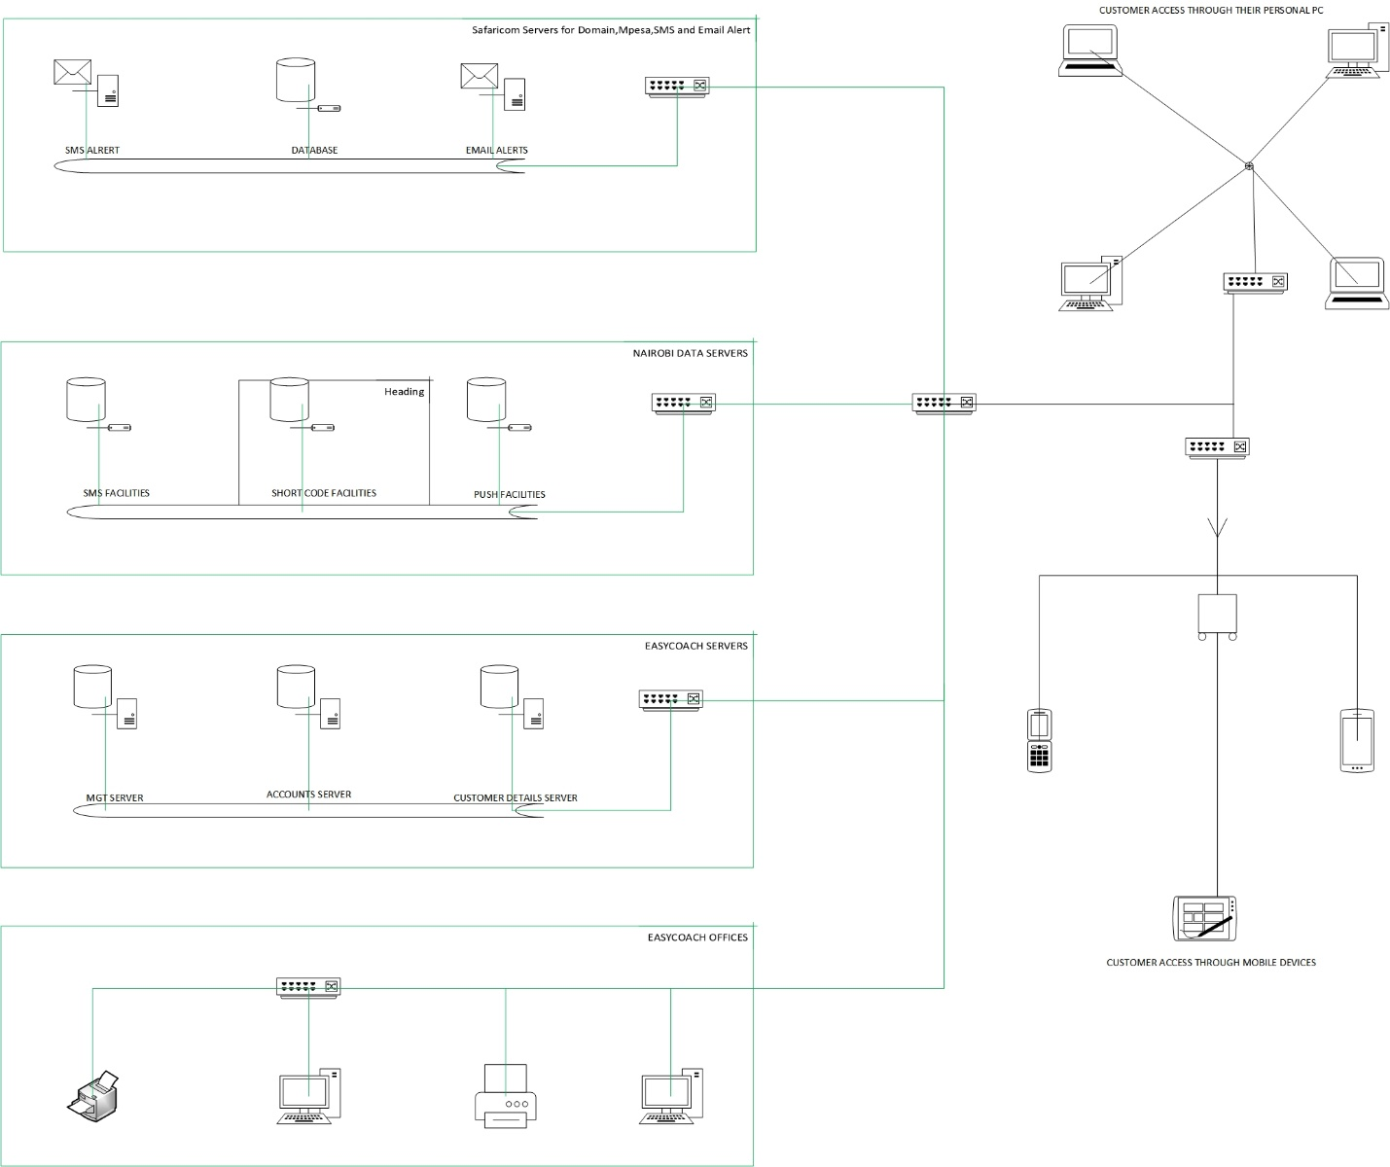

This system will have the following functionalities implemented on it;

**Easy Ticket Booking Module**

The booking module will comprise of: -

* **Destinations –** Customer can check and select desired departures to various destination.
* **Ticket reservation** - Customers just have to select a date, a start and end point, and add personal details. Customers can book one way or round trip for return ticket.
* **Seat selection –** Customer can browse through and select a seat he/she desires.

|  |  |  |  |  |
| --- | --- | --- | --- | --- |
| # | **CUSTOMER OPERATION** | **REQ.** | **PROVIDED** | **ACCESS** |
|  | Select destination | Dropdown list | Yes | Customer |
|  | Search for ticket | Popup | Yes | Customer |
|  | Input personal details | Form | Yes | Customer |
|  | Book for a return ticket | Radio button | Yes | Customer |
|  |  |  |  |  |

|  |  |  |  |  |
| --- | --- | --- | --- | --- |
| **#** | **STAFF OPERATION** | **REQ.** | **PROVIDED** | **ACCESS** |
|  | Provision supper user | NA | NA | System |
|  | Provision customer(Booking, Search Ticket, Seat Reservation, Payment) | Form | YES | Customer |
|  |  |  |  |  |

|  |  |  |  |
| --- | --- | --- | --- |
| **#** | **ROLL** | **ACCESS** | **COMMENTS** |
|  | SUPER-USER | ALL | Can do everything |
|  | ACCOUNTANT | PAYMENTS |  |
|  | OPERATION MANGER | BUS SCHEDULING  ROUTE MANAGEMENT  TICKET CANCELLATION |  |
|  |  |  |  |
|  |  |  |  |

**Easy Ticket Payment Module**

This system payment module will have/do the following: -

* Ticket payment process
* Process Payments
* Limit amount to be paid

|  |  |  |  |
| --- | --- | --- | --- |
| **#** | **OPERATION** | **PROVIDED** | **COMMENTS** |
|  |  |  |  |
|  |  |  |  |
|  |  |  |  |

**Easy Ticket Alerts Module**

This system will have the following alert modes: -

* **Emails –** This will be a system triggered alert to customers’ email address with the ticket details such as personal details, date of the booking, route name, seat number, amount paid, travel date, reporting time and departure time.
* **SMS-**This will be a system triggered alert to customers’ mobile number. Whenever any payment is made, an acknowledgment SMS will be sent to the customer notifying him or her that the payment made has been received.

|  |  |  |  |  |
| --- | --- | --- | --- | --- |
| **#** | **SMS ALERT TRIGER** | **TRIGGER** | | **COMMENTS** |
|  | Ticket booking payment | **AS** | |  |
|  |  |  | |  |
|  | | |  | |
| **#** | **E-MAIL ALERT TRIGER** | **TRIGGER** | | **COMMENTS** |
| **1.** | Reservation made | **AS** | |  |
| **2.** |  |  | |  |

**Reports**

The following are the reports which will be generated from the system: -

|  |  |
| --- | --- |
| **#** | **REPORTS** |
| **1.** | Passenger Details |
| **2.** | Payment Details |
| **3.** | Bus Details |
| **4.** |  |

## High-Level Requirements

This system will be a web based application, that is, any device with internet access and web browser, will be able to access it. In addition, there will be SMS capabilities that can be utilized by any device with SMS capabilities.

This system will have the following capabilities;

* Ability to allow both internal and external users to access the application without downloading any software.
* Ability to interface with the company’s database
* Ability to incorporate automated notifications based on business rules

## Deliverables

* Back-end software that is hosted locally
* UI Prototype for both customers and Easy Coach management.
* Management web based application, accessible through specific authorized computers.
* Members responsive web based application accessible.
* User documentation manual.
* Technical documentation

## Affected Parties

* Easy Coach Management
* Customers

## Affected Business Processes or Systems

* Seat reservation
* Ticket payment
* Bus schedule enquires
* Travel reminders

## Specific Exclusions from Scope

In this first phase, the following will not be included in the application although they will be included in the subsequent phases: -

* Direct MPESA/AIRTEL MONEY connection through the API which will enable automatic notification to the customer from either MPESA or AIRTEL MONEY that payment has been made to EASY COACH LIMITED mobile money accounts.
* Integration with existing systems (if any).

## Implementation Plan

The project will kick off with the implementation of stubs necessary to enable development of the prototype.

After the stubs, the UI prototype will be developed. Once the prototype has been developed, the EASYCOACH officials will go through it and approve of it. This stage is to ensure that all required functionalities have been factored and that the user experience (UX) is excellent.

Email and SMS alerts will be integrated once the system is finished.

Signing off, commissioning and training will follow thereafter.

## High-Level Timeline/Schedule

|  |  |  |  |  |
| --- | --- | --- | --- | --- |
| # | Date | Description | Dep. | Comments |
| 1 | 05/2/2018 – 09/2/2018 | Wireframe |  |  |
| 2 |  |  | #1 |  |
| 3 |  |  | #2 |  |
| 4 |  |  | #3 |  |
| 5 |  |  | #4 |  |
| 6 |  |  | #4 |  |

## Approval and Authority to Proceed

We approve the project as described above, and authorize the team to proceed.

|  |  |  |  |
| --- | --- | --- | --- |
| Name | Title | Signature | Date |
| Felix Otieno Okoth | Mr. |  | --/02/2018 |
|  |  |  |  |
|  |  |  |  |